POWER SUPPLY   
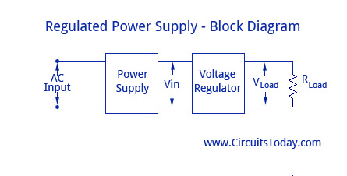

A regulated power supply essentially consists of an ordinary power supply and a voltage regulating device, as illustrated in the figure. The output from an ordinary power supply is fed to the voltage regulating device that provides the final output. The output voltage remains constant irrespective of variations in the ac input voltage or variations in output (or load) current.

**Transformer**

A step down transformer is used to step down the voltage from the input AC to the required voltage of the electronic device. The input of the transformer being 230 Volts AC mains, the output is provided to a full bridge rectifier circuit.

**Full Wave Rectifier Circuit**

The FWR consists of 4 diodes which rectifies the output AC voltage or current from the transistor to its equivalent DC quantity. As the name implies the FWR rectifies both half’s of the AC input. The rectified DC output is given as input to the Voltage regulator.

**Voltage regulator IC**

**7805** is a 5V fixed three terminal positive **voltage regulator IC**. The **IC** has features such as safe operating area protection, thermal shut down, internal current limiting which makes the **IC** very rugged. Output currents up to 1A can be drawn from the **IC** provided that there is a proper heat sink.